Performance Summary (to month-end)

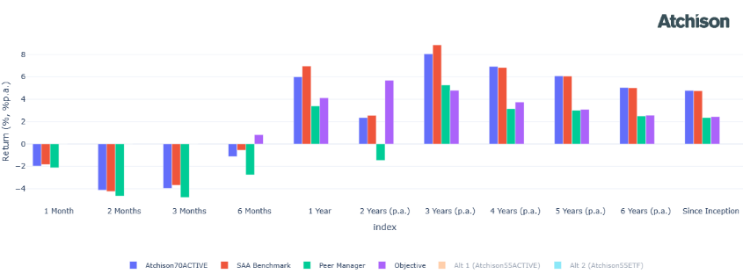

Cumulative Returns

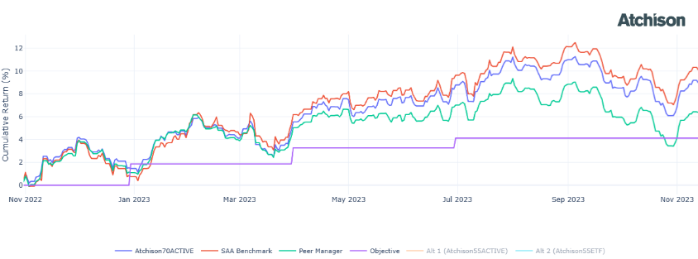

Drawdown Analysis

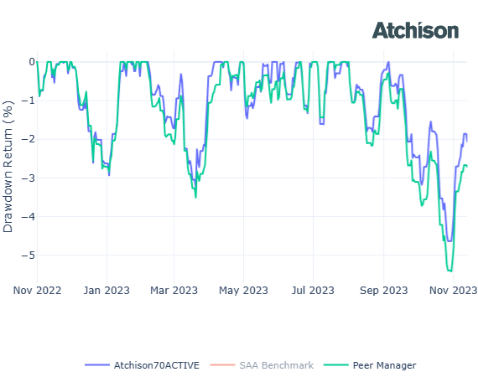

Mandate Overview

Investment Strategy

Asset Allocation



